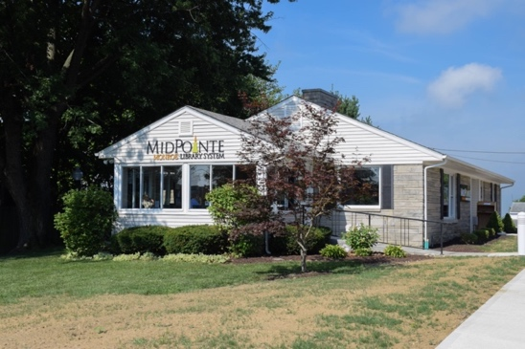

Draft Agenda
Board of Trustees—MidPointe Library System
April 20, 2022
1:00 p.m. Regular Meeting
Monroe Branch – Rothwell Room

- Call to Order

- Opening Exercise

- Roll Call
- Adoption of Agenda

- Public Comment

- Approval of Minutes (Regular Meeting, March 16, 2022)
- Fiscal Officer’s Report
  - Financial Report, Investments, and Donations

- Director’s Report
  - Yankee Road / Liberty Project Updates

- Public Services Report
- Community Engagement Report
- Human Resources Report
- Board Comments
- Adjournment
Enclosures:
March 2022 Financial Report
Draft of the March 16, 2022, Meeting Minutes
Director’s Report
Public Services Report
Community Engagement Report
HR Report

