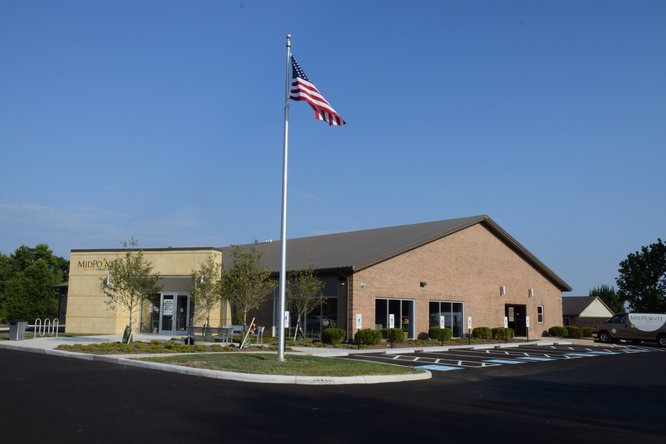

Draft Agenda
Board of Trustees—MidPointe Library System
August 17, 2022
1:00 p.m. Regular Meeting
Trenton Branch

- Call to Order
- Opening Exercise

- Roll Call
- Adoption of Agenda

- Public Comment
  - Middletown City Liaison Update

- Approval of Minutes
Approve the July 20, 2022, Meeting Minutes
- Facilities Subcommittee Report
- Fiscal Officer’s Report
  - July 2022 Financial Report, Investments, and Donations

- Director’s Report
  - Liberty / Yankee Road Update
- Public Services Report
- Community Engagement Report
- Human Resources Report

- Board Comments
- Adjournment

Enclosures:

Draft of the July 20, 2022 Meeting Minutes
July 2022 Financial Report
Director’s Report
Liberty/Yankee Road Property Update
Community Engagement Report
Human Resources Report

