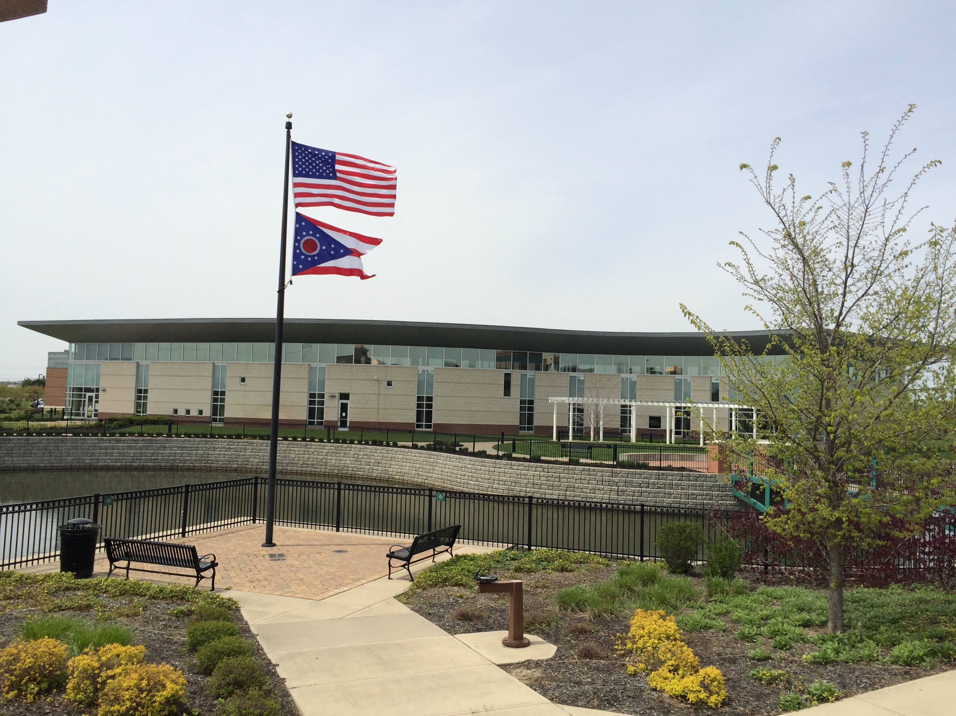

Draft Agenda
Board of Trustees—MidPointe Library System
February 16, 2022
1:10 p.m. Regular Meeting
West Chester Branch

- Call to Order
- Opening Exercise

- Roll Call
- Adoption of Agenda

- Public Comment
  - Middletown City Liaison Update

- Approval of Minutes
Approve the January 19, 2022, Organizational Meeting Minutes
- 2022 Board Committee Roster
- Fiscal Officer’s Report
  - January 2022 Financial Report, Investments, and Donations

- Director’s Report
  - Liberty/Yankee Road – RFQ Update
  - Credit Card Audit Report

- Public Services Report
- Community Engagement Report
- Human Resources Report
  - Staffing and HR Updates

- Board Comments
- Adjournment

Enclosures:

Draft of the January 19, 2022 Organizational Meeting Minutes
January 2022 Financial Report
Director’s Report
Public Services Report
Community Engagement Report
Staffing and HR Updates
2022 Board Committee Roster
Credit Card Audit Report

