FINAL Agenda
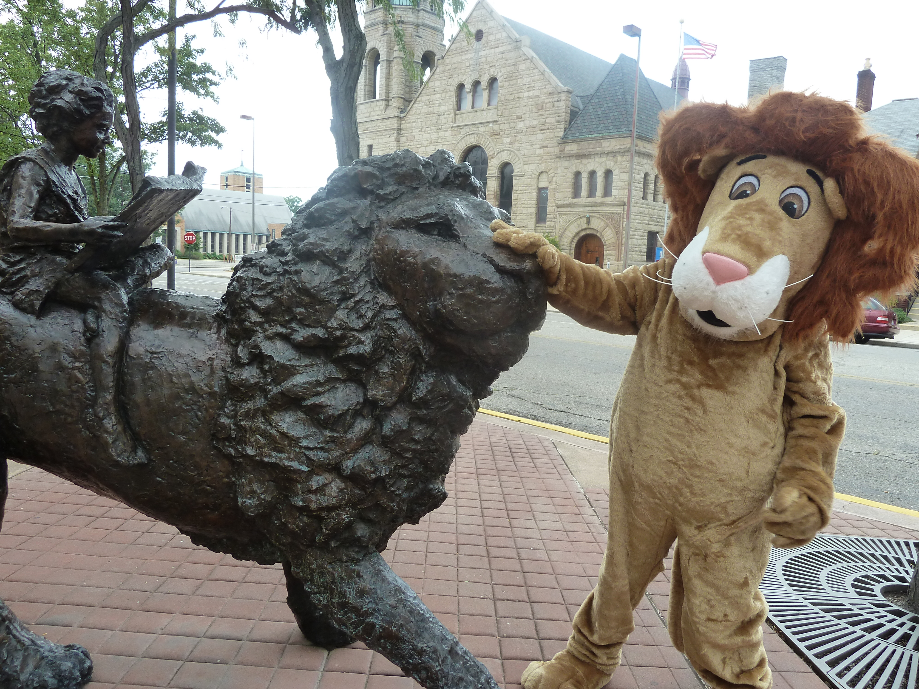
Board of Trustees—MidPointe Library System
January 19, 2022
1:00 pm Organizational Meeting
Middletown Branch – Community Room

- Call to Order by President Pro Tem

- Opening Exercise

- Roll Call

- 2022 Board
  - Oath of Office, New Trustees
    - Michael Huff
    - Deborah Houser
    - Bill Jones
  - Oath of Office, Election of Officers
The President Pro Tem will conduct the election of board officers.
  - Board Meeting Calendar (draft)
  - Board Committees (draft)
- Adoption of Agenda

- Public Comment

- Approval of Minutes (December 14, 2021)
- Fiscal Office
  - Hiring of the Fiscal Officer
  - Oath of Office, Fiscal Officer
  - Oath of Office, Deputy Fiscal Officer
- Fiscal Officer’s Report
  - Financial Report, Investments, and Donations
  - Resolution for the Appreciation and Acknowledgment of Staff, Volunteers, and Citizens
  - RFQ (Yankee Road – Liberty Project)
  - Credit Card Policy Update

- Director’s Report
  - Annual Statistical Report
  - Public Policy Manual Update
  - Project Updates (Liberty & West Chester)

- Public Services Report
- Community Engagement Report

(page 2)
- Human Resources
  - Staffing Updates
  - Employee Handbook Update

- Board Comments
- Adjournment

Enclosures:

Draft of 2022 Board Calendar
Draft of 2022 Board Committee Rosters
Draft of the December 14, 2021 Meeting Minutes
December 2021 Financial Report
Resolution for the Appreciation and Acknowledgment of Staff, Volunteers, and Citizens
Credit Card Policy Update
Director’s Report
Public Policy Manual Update
Public Services Report
Community Engagement Report
Human Resources Report – Staffing Updates
Employee Handbook Update

