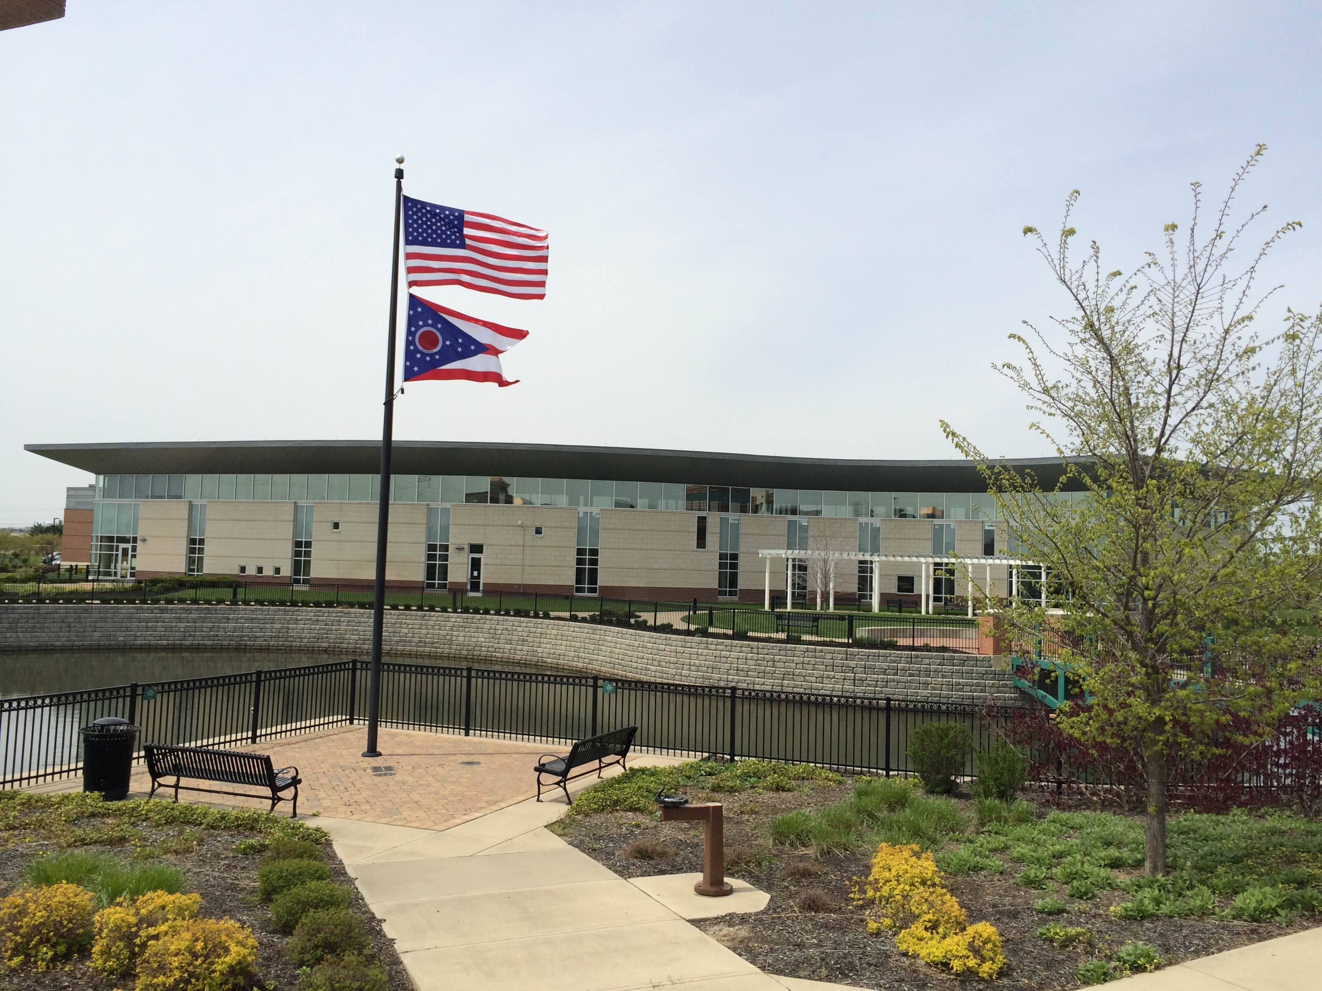

Agenda
Board of Trustees—MidPointe Library System
November 16, 2021
4:00 p.m. Regular Meeting
West Chester Branch

- Call to Order
- Opening Exercise

- Roll Call
- Adoption of Agenda

- Public Comment

- Approval of Minutes
Approve the October 19, 2021 Meeting Minutes
- Fiscal Officer’s Report
  - October 2021 Financial Report, Investments, and Donations
  - Butler County PLF (Census Update)
  - Revised Appropriations 2021
  - Appropriations 2022
  - Property advances from Butler County

- Director’s Report
  - West Chester Update
  - Liberty Update
    - Legal Review
    - RFQ
  - Foundation By-Laws (draft)
  - Public Policy Manual Updates

- Public Services Report
- Community Engagement Report
- Human Resources Report
  - Staffing and HR Updates
  - Employee Handbook Updates
- Board Comments
  - Trustee Recruitment
- Adjournment

Enclosures:

Draft of the October 19, 2021 Meeting Minutes
October 2021 Financial Report
Director’s Report
Public Services Report
Community Engagement Report
Staffing and HR Updates
Foundation By-Laws Draft
Public Policy Manual Updates (draft)
Employee Handbook Updates (draft)

