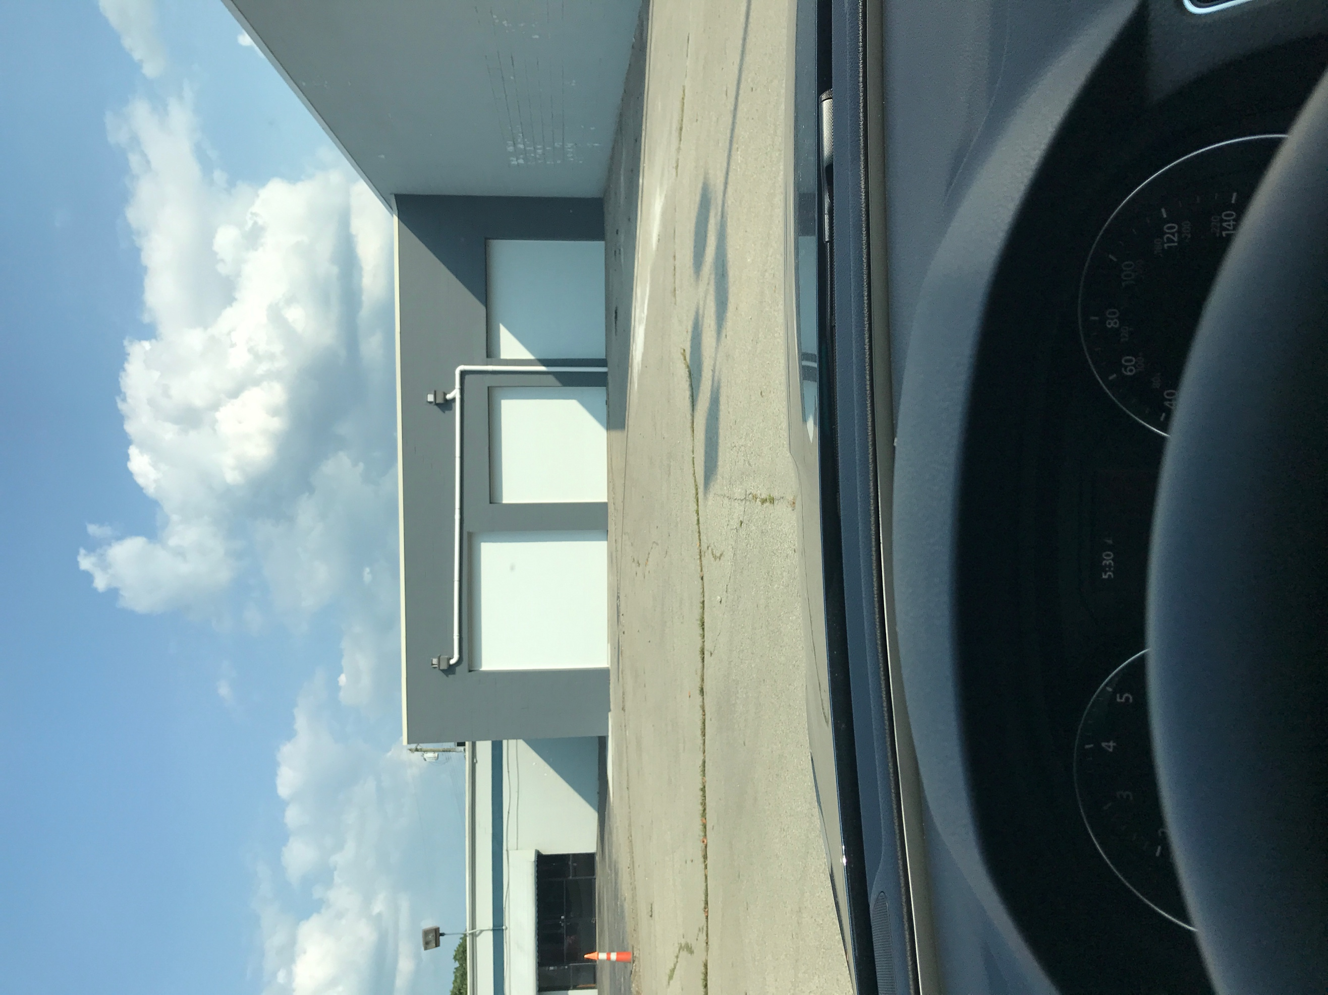

Final Agenda
Board of Trustees—MidPointe Library System
October 19, 2021
4:00 p.m. Regular Meeting
Library on Wheels Garage – Middletown

- Call to Order
- Opening Exercise

- Roll Call
- Adoption of Agenda

- Public Comment

- Approval of Minutes
Approve the September 21, 2021 Meeting Minutes
- Fiscal Officer’s Report
  - September 2021 Financial Report, Investments, and Donations

- Director’s Report
  - West Chester Update
  - Liberty Update
  - Foundation By-Laws (draft)

- Public Services Report
- Community Engagement Report
- Human Resources Report
  - Staffing and HR Updates
- Board Comments
  - Trustee Recruitment
  - Meeting Calendar
- Adjournment

Enclosures:

Draft of the September 21, 2021 Meeting Minutes
September 2021 Financial Report
Director’s Report
Public Services Report
Community Engagement Report
Staffing and HR Updates
Foundation By-Laws Draft

