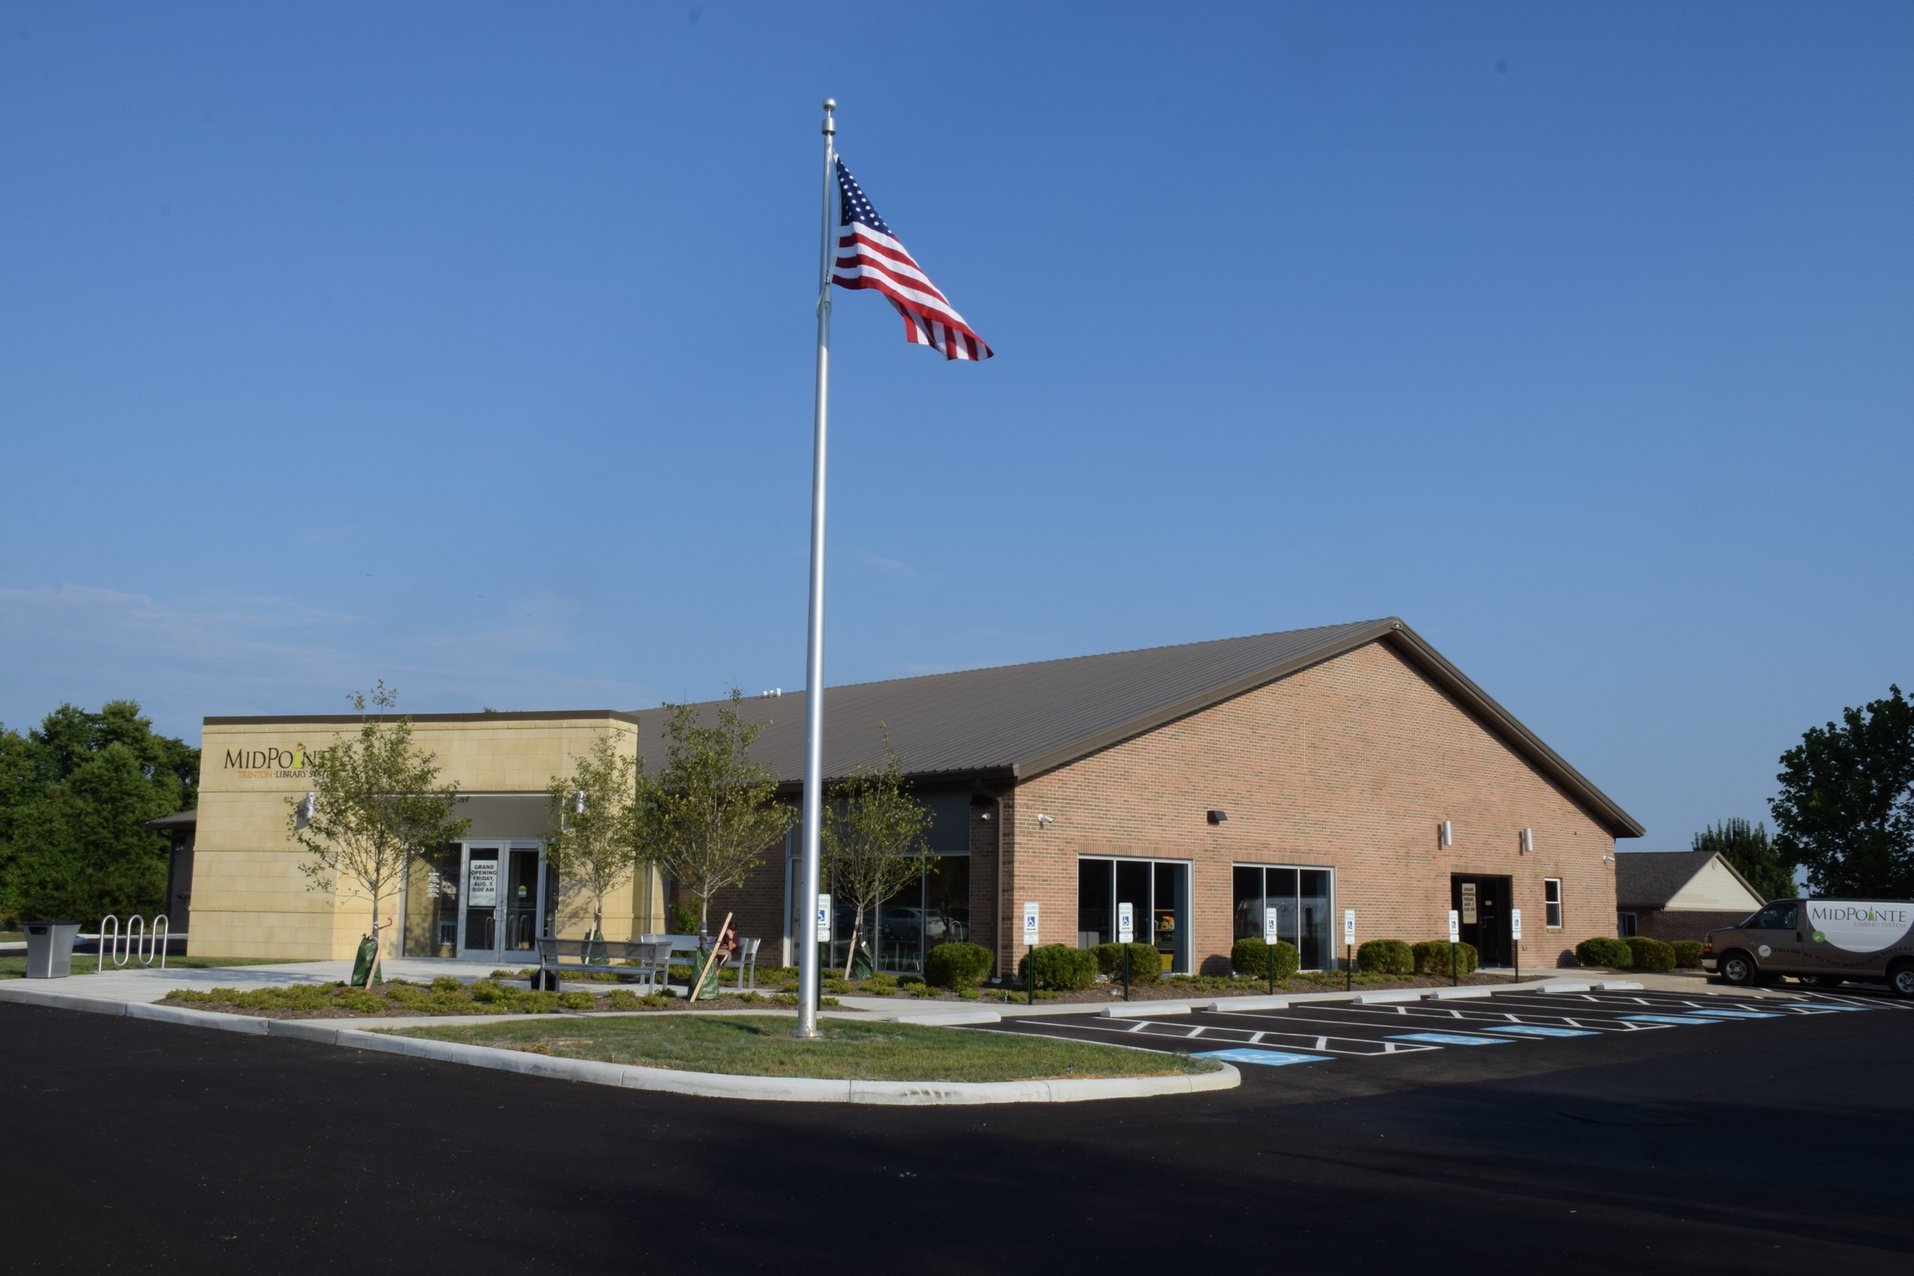
Draft Agenda
Board of Trustees—MidPointe Library System
December 14, 2022
1:00 p.m. Regular Meeting
Trenton Branch

- Call to Order
- Opening Exercise

- Roll Call
- Adoption of Agenda

- Public Comment

- Approval of Minutes
Approve the November 16, 2022 Meeting Minutes
- Fiscal Officer’s Report
  - November 2022 Financial Report, Investments, and Donations
  - 2023 Appropriations
  - Memorial Fund Resolution

- Director’s Report
  - Liberty Construction Schedule (tentative)

- Public Services Report
- Community Engagement Report
  - LSTA Grant (Ally Doliboa)
- Human Resources Report
  - Staffing and HR Updates
  - Executive Session
Under the authority of O.R.C. 121-22 (g) (1) To consider the employment of a public employee or official unless the public employee or official requests a public hearing.
- Board Comments
- Adjournment
Enclosures:

Draft of the November 16, 2022 Meeting Minutes
November 2022 Financial Report
2023 Appropriations Documents
Director’s Report
Liberty Construction Schedule
Public Services Report
Community Engagement Report
Staffing and HR Updates

