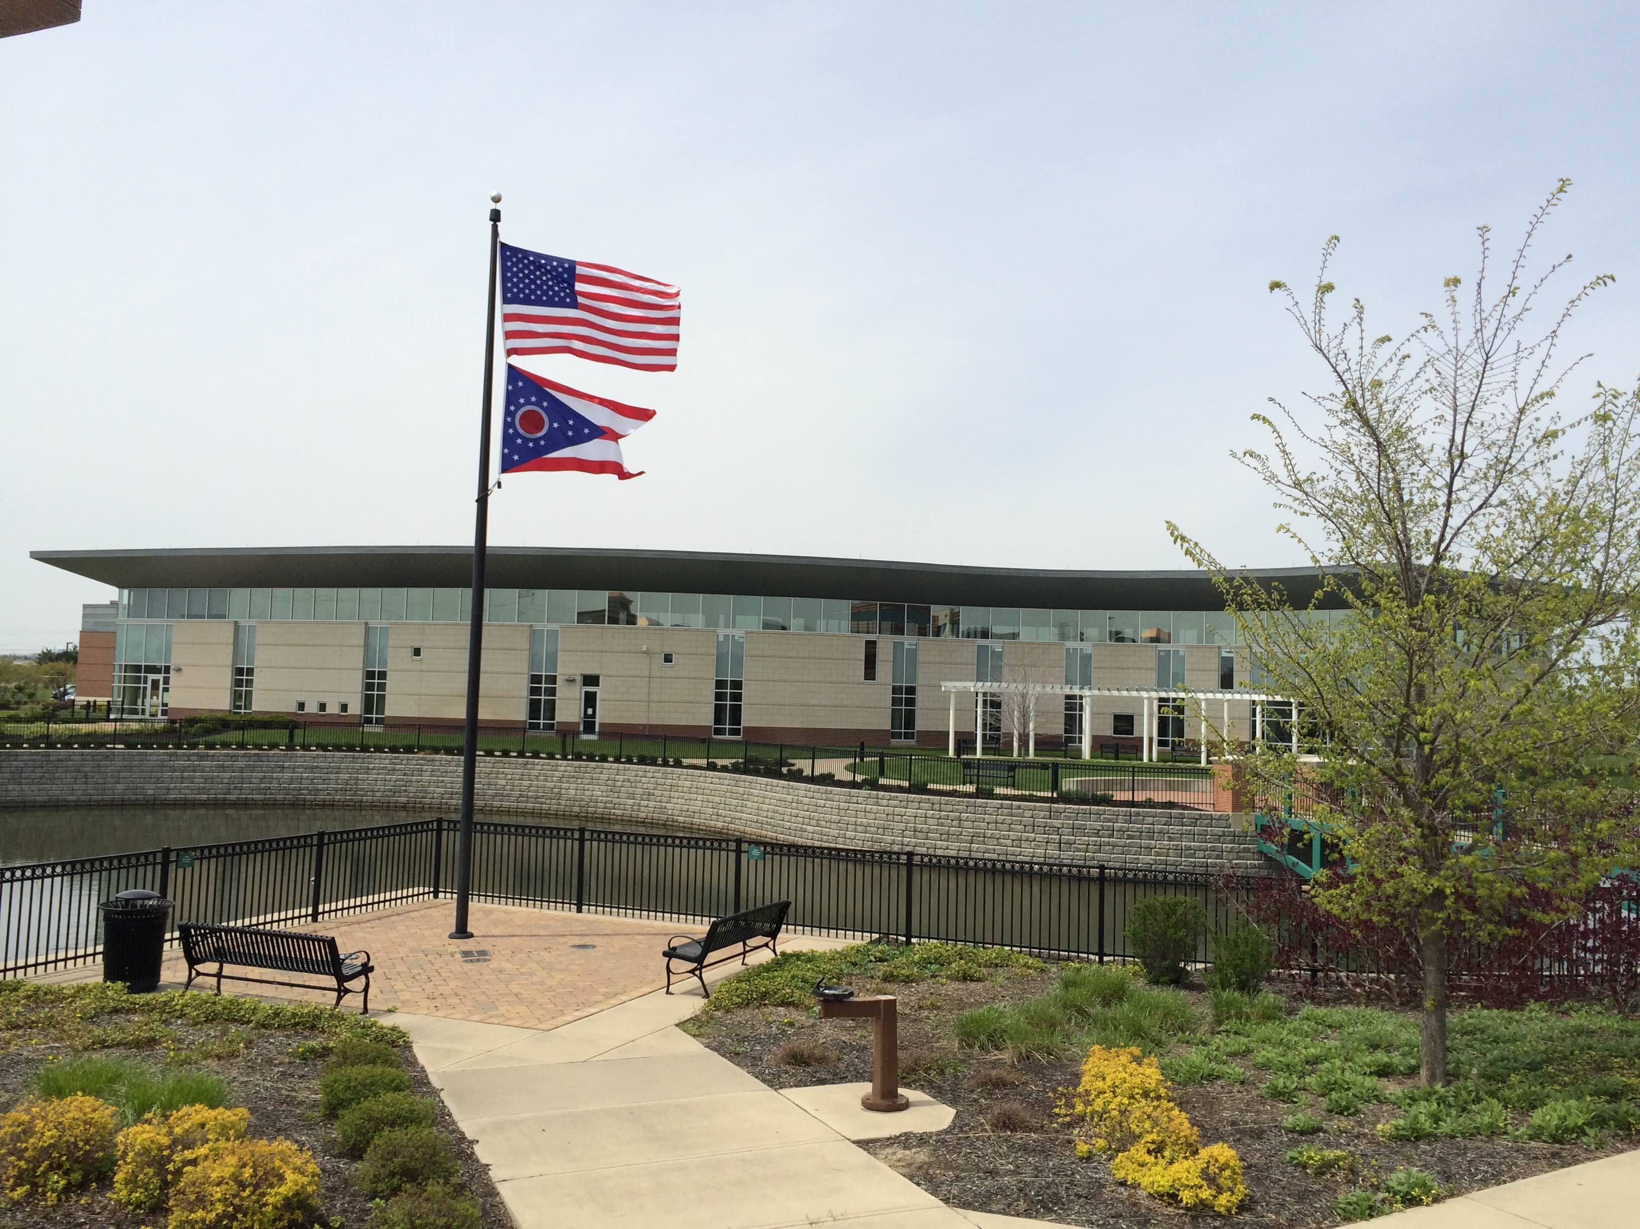

Draft Agenda
Board of Trustees—MidPointe Library System
February 15, 2023
1:00 p.m. Regular Meeting
West Chester Branch

- Call to Order
- Opening Exercise

- Roll Call
- Adoption of Agenda

- Public Comment
  - Middletown City Liaison Update

- Approval of Minutes
Approve the January 18, 2023, Organizational Meeting Minutes
- Fiscal Officer’s Report
  - January 2023 Financial Report, Investments, and Donations

- Director’s Report
  - Liberty Branch Project
  - Trenton Sidewalk Project
  - Credit Card Audit Report

- Public Services Report
- Community Engagement Report
- Human Resources Report
  - Staffing and HR Updates

- Board Comments
- Adjournment

Enclosures:

Draft of the January 18, 2023 Organizational Meeting Minutes
January 2023 Financial Report
Director’s Report
Public Services Report
Community Engagement Report
Staffing and HR Updates
Credit Card Audit Report

