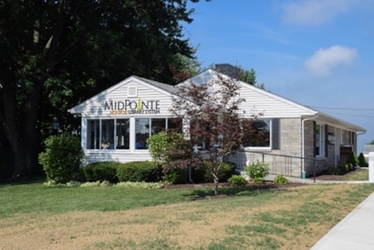

Meeting Agenda
Board of Trustees—MidPointe Library System
July 2, 2024
11:00 a.m. Special Meeting
Monroe Branch – Rothwell Room
- Call to Order

- Opening Exercise

- Roll Call
- Adoption of Agenda

- Public Comment
- Resolution
- June 2024 action items (board approvals required)
  - May 15, 2024 Minutes
  - May 2024 Financial Report
  - May 2024 Human Resources Report
- Executive Director Update
- Board Comments
- Adjournment

Enclosures:
Draft of the May 15, 2024, Meeting Minutes
May 2024 Financial Report
May 2024 Human Resources Report

