Draft Agenda
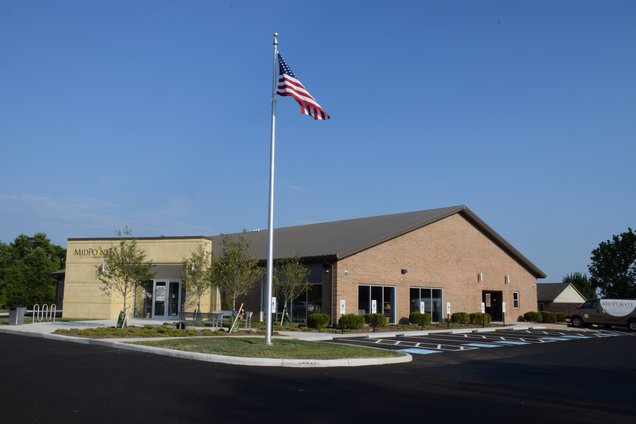
Board of Trustees—MidPointe Library System
August 21, 2024
1:00 p.m. Regular Meeting
Trenton Branch
- Call to Order
- Opening Exercise

- Roll Call
- Adoption of Agenda

- Public Comment
- Approval of Minutes
Approve the June 20, 2024, Special Meeting Minutes
Approve the July 2, 2024, Special Meeting Minutes
- Fiscal Officer’s Report
  - June 2024 Financial Report, Investments, and Donations
  - July 2024 Financial Report, Investments, and Donations
  - Audit Results
  - Levy Update
  - DJB Progress Fund
- Director’s Report
- Facilities Report - Liberty/Yankee Road Construction
  - Change Order Summary
- Public Services Report
- Community Engagement Report
- Human Resources Report
  - Staffing and HR Updates
  - Education Assistance Program
  - Salary Philosophy

- Board Comments
- Adjournment
Enclosures:
Draft of the June 20, 2024, Special Meeting Minutes
Draft of the July 2, 2024, Special Meeting Minutes
June 2024 Financial Report
July 2024 Financial Report
Director’s Report
Change Order Summary
Public Services Report
Community Engagement Report
Staffing and HR Updates
Education Assistance Program

