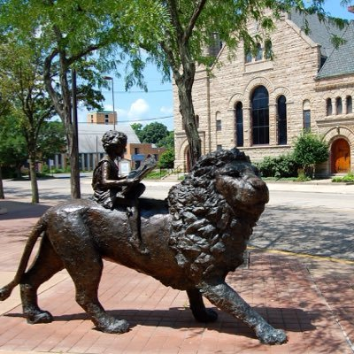

Draft Agenda
Board of Trustees—MidPointe Library System
October 16, 2024
1:00 p.m. Regular Meeting
Middletown Branch Board Room

- Call to Order

- Opening Exercise

- Roll Call
- Adoption of Agenda

- Public Comment

- Approval of Minutes (Regular Meeting, September 18, 2024)
- Fiscal Officer’s Report
  - Financial Report, Investments, and Donations
  - Butler County Resolution

- Director’s Report
  - Board By-Laws
  - Innovation Pointe Middletown (Noah Howells)

- Facilities Report
- Public Services Report
- Community Engagement Report
- Human Resources Report
  - Staff Day Update
  - Employee Handbook
- Board Comments
- Adjournment
Enclosures:
Financial Report for September 2024
Draft of the September 18, 2024, Meeting Minutes
Butler County Resolution
Director’s Report
Board By-Laws
Community Engagement Report
HR Report
Employee Handbook

