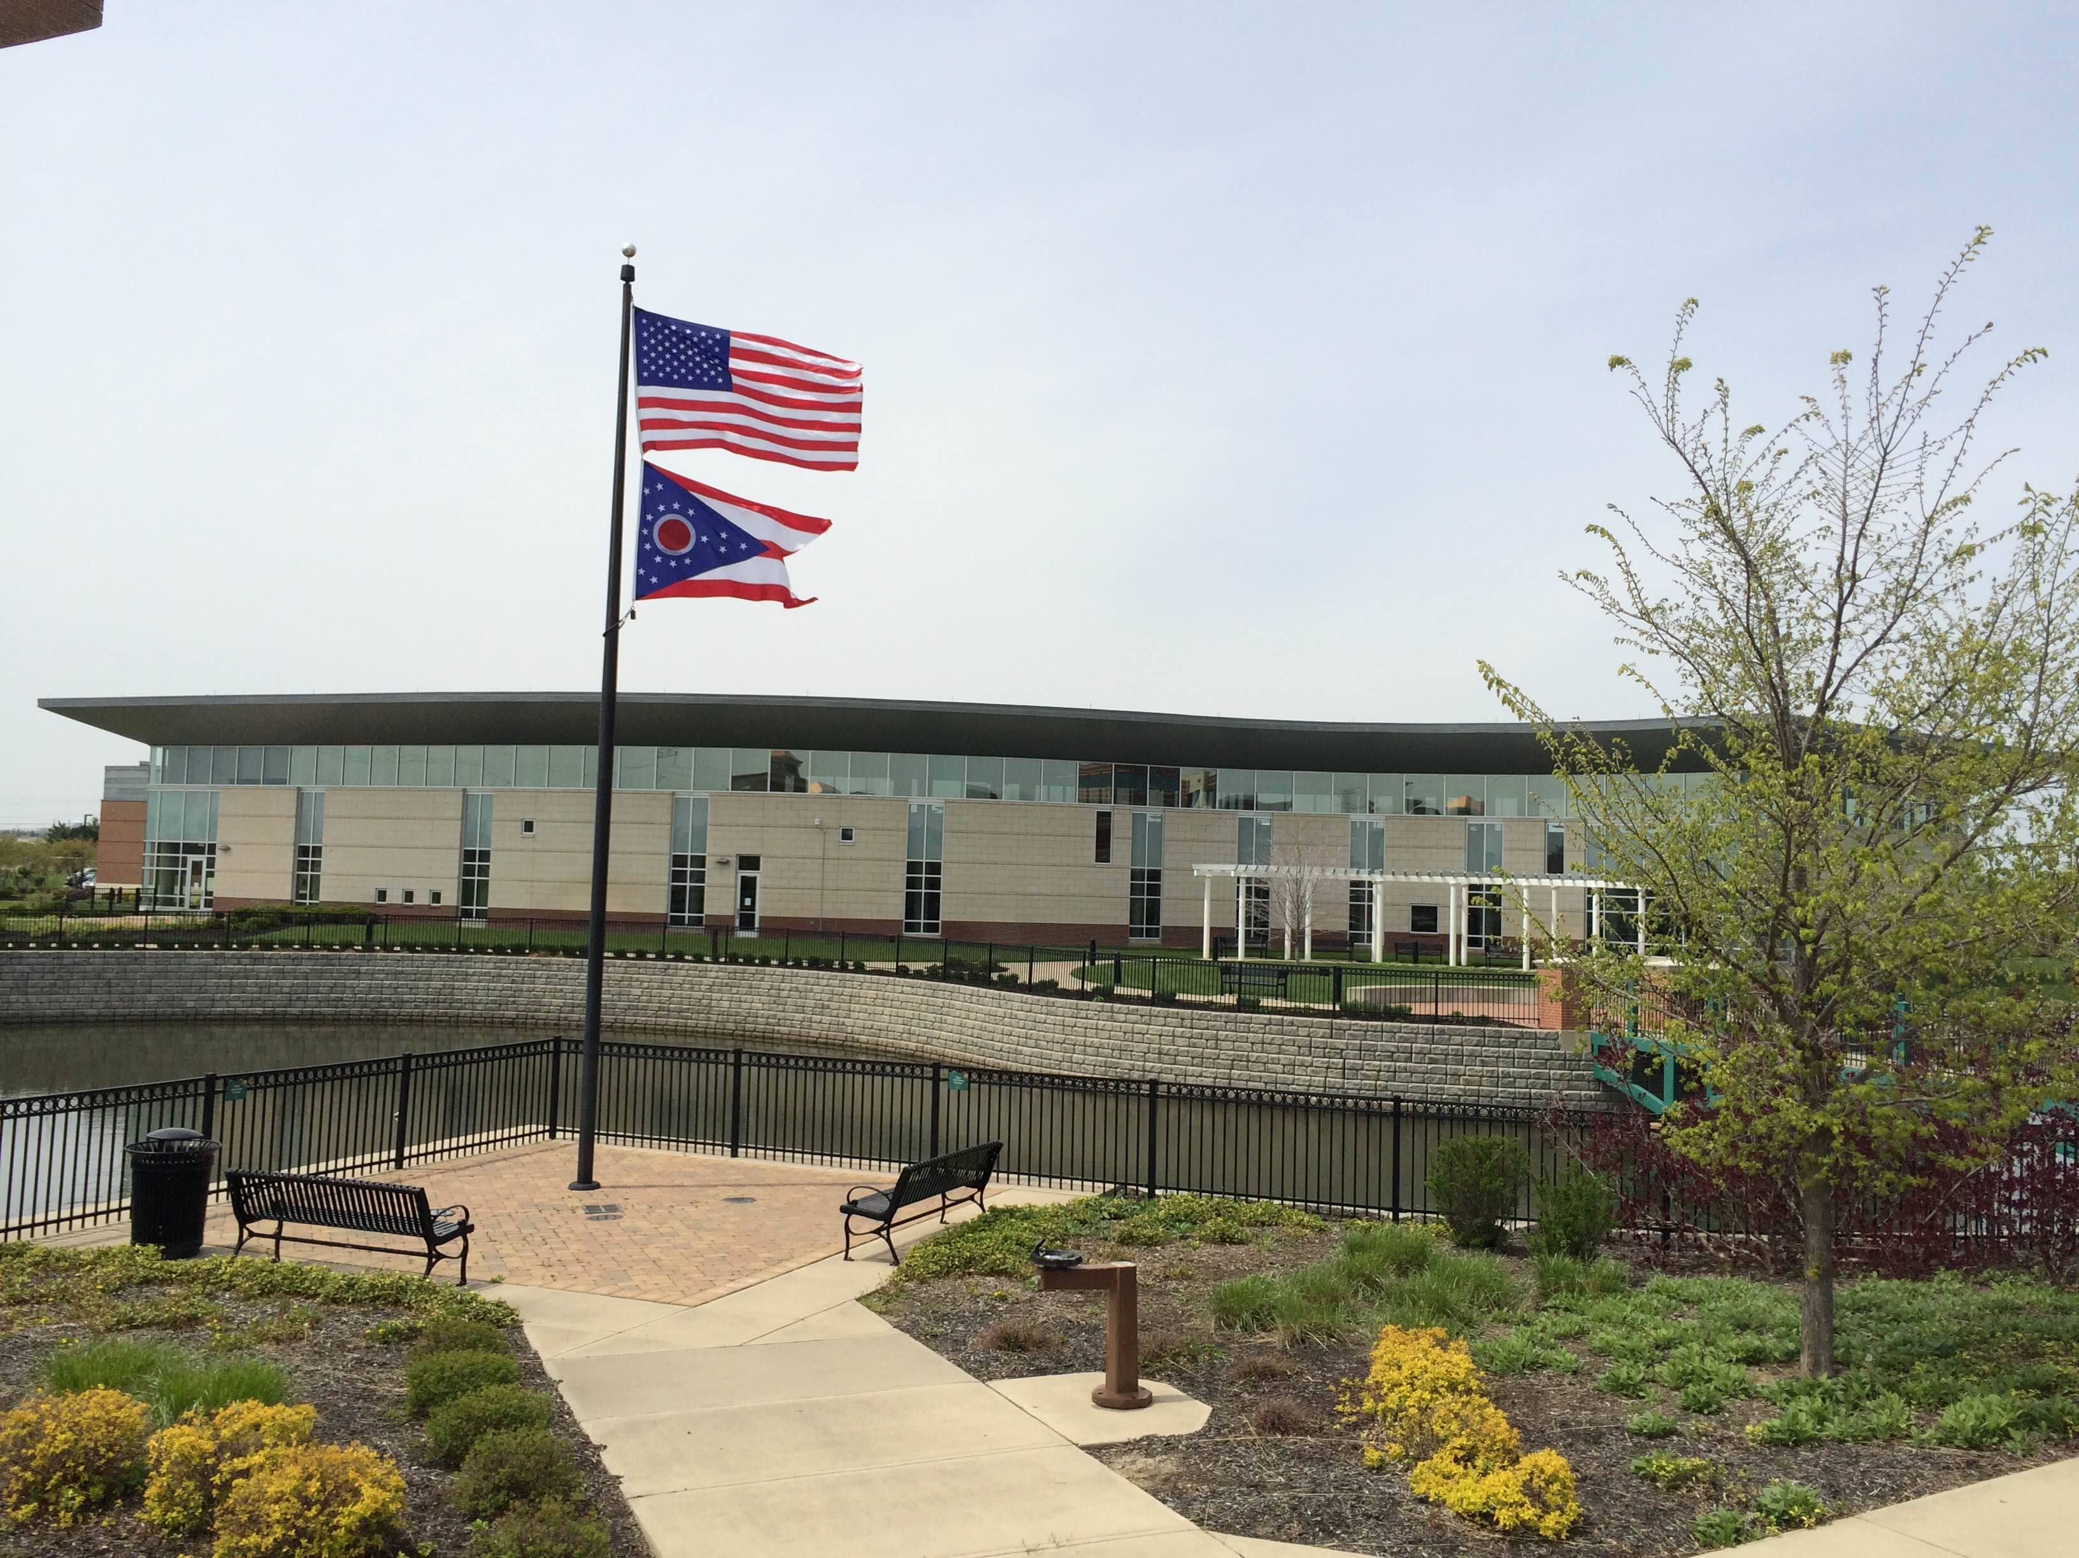

Draft Agenda
Board of Trustees—MidPointe Library System
November 20, 2024
1:00 p.m. Regular Meeting
West Chester Branch

- Call to Order
- Opening Exercise

- Roll Call
- Adoption of Agenda

- Public Comment

- Approval of Minutes
Approve the October 16, 2024, Meeting Minutes
- Fiscal Officer’s Report
  - October 2024 Financial Report, Investments, and Donations
  - Budget 2025 Update
- Levy Update

- Director’s Report
  - Yankee Road Easements

- Facilities Report
  - Yankee Road Change Orders
- Public Services Report
- Community Engagement Report
- Development Report
  - 501(c)3 Status
  - Dolly Parton Imagination Library of Ohio
  - Annual Campaign
- Human Resources Report
  - Staffing and HR Updates
  - HR Subcommittee Report
  - Executive Session
Under the authority of O.R.C. 121-22 (g) (1) To consider the compensation of a public employee or official unless the public employee or official requests a public hearing.
  - Compensation
- Board Comments
- Adjournment
Enclosures:
Draft of the October 16, 2024 Meeting Minutes
October 2024 Financial Report
Director’s Report
Community Engagement Report

