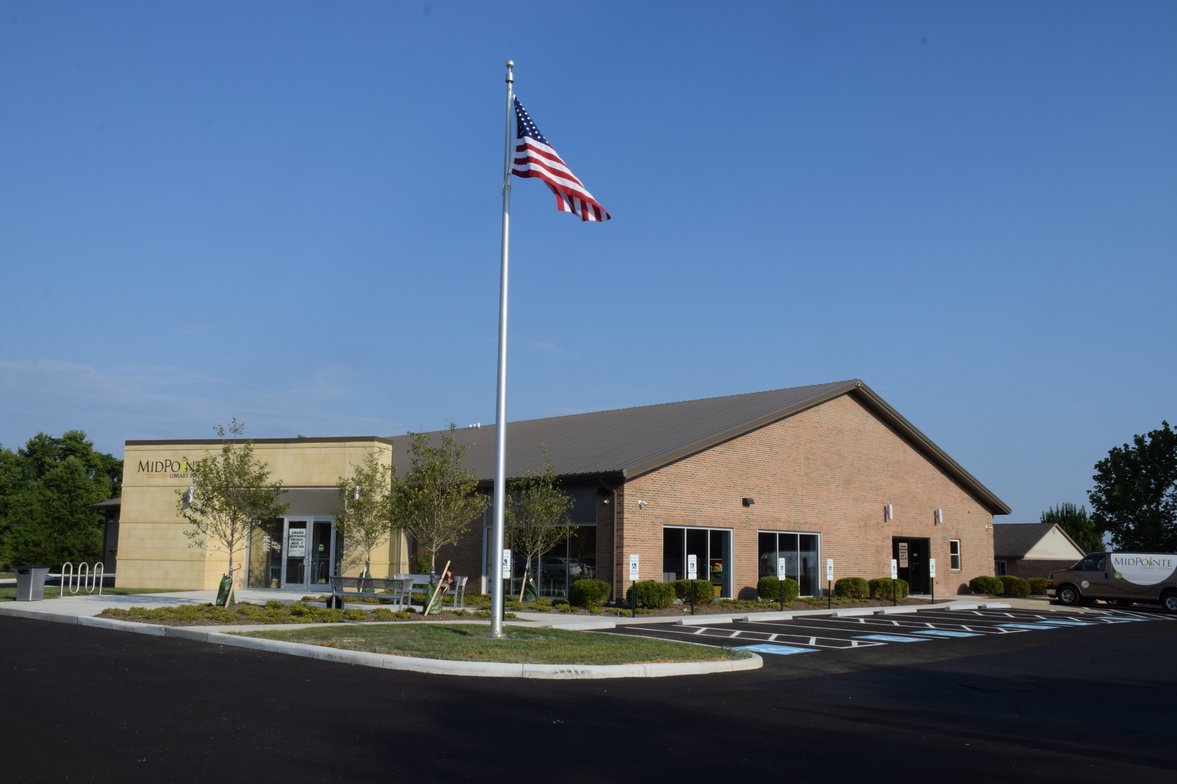
Draft Agenda
Board of Trustees—MidPointe Library System
December 18, 2024
1:00 p.m. Regular Meeting
Trenton Branch

- Call to Order
- Opening Exercise

- Roll Call
- Adoption of Agenda

- Public Comment

- Approval of Minutes
Approve the November 20, 2024 Meeting Minutes
- Fiscal Officer’s Report
  - November 2024 Financial Report, Investments, and Donations
  - Resolution - 2024 Annual Appropriation
  - Resolution - Requesting The City Council of Middletown Submit to Electors a Levying Tax
  - Motion - Transfer Cash from General Fund to Capital Improvement Fund

- Director’s Report
- Facilities Report

- Public Services Report
- Community Engagement Report
- Human Resources Report
  - Staffing and HR Updates
  - Employee Handbook
- Board Comments
- Adjournment
Enclosures:

Draft of the November 20, 2024 Meeting Minutes
November 2024 Financial Report
2024 Annual Resolution
Director’s Report
Public Services Report
Community Engagement Report
Employee Handbook

