DRAFT Agenda

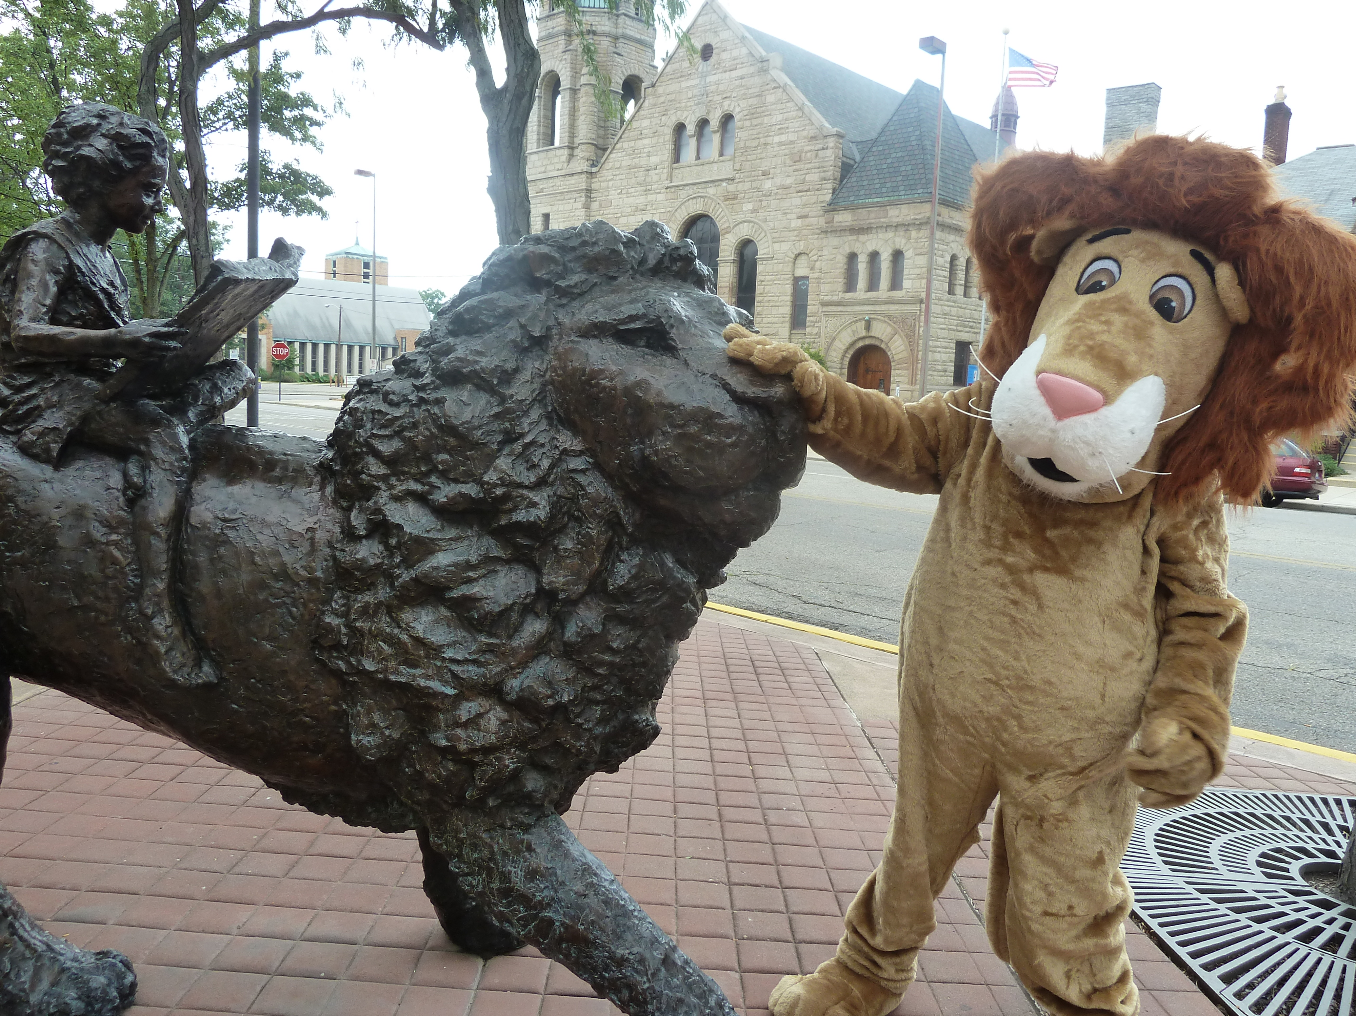

Board of Trustees—MidPointe Library System

January 22, 2025

1:10 pm Organizational Meeting

Middletown Branch – Board Room

1. Call to Order by President Pro Tem
2. Opening Exercise
3. Roll Call
4. 2025 Board
   1. Oath of Office (3), Election of Officers  
      The President Pro Tem will conduct the election of board officers.
   2. Board Meeting Calendars (3) (drafts)
   3. Board Committees (draft)
5. Adoption of Agenda
6. Public Comment
7. Approval of Minutes
   1. Special Meeting, December 11, 2024
   2. Regular Meeting, December 18, 2024
8. Fiscal Office
   1. Hiring of the Fiscal Officer
   2. Oath of Office, Fiscal Officer
   3. Oath of Office, Deputy Fiscal Officer
9. Fiscal Officer’s Report
   1. Financial Report, Investments, and Donations
   2. Resolution for Tax Advances from Butler County
   3. Appreciation and Acknowledgment of Staff, Volunteers, and Citizens
      1. Appreciation Handout
      2. Resolution for the Appreciation and Acknowledgment of Staff, Volunteers, and Citizens
10. Director’s Report
    1. Annual Statistical Report
    2. Public Policy Manual Updates (for February Meeting)
11. Facilities Report
    1. Liberty Project Updates
12. Public Services Report
13. Community Engagement Report

(page 2)

1. Human Resources
   1. Staffing Updates
   2. Employee Handbook
2. Board Comments
3. Adjournment

Enclosures:

Draft of three (3) Oath of offices (Board Officers)

Draft of three (3) 2025 Board Calendars

Draft of 2025 Board Committee Rosters

Draft of the December 11, 2024 Special Meeting Minutes

Draft of the December 18, 2024 Meeting Minutes

Oath of office for FO

Oath of office for DFO

December 2024 Financial Report

Resolution for Tax Advances from Butler County

Resolution for the Appreciation and Acknowledgment of Staff, Volunteers, and Citizens

Handout for the Appreciation and Acknowledgement of Staff, Volunteers, and Citizens

Director’s Report

Public Services Report

Community Engagement Report

Human Resources Report – Staffing Updates