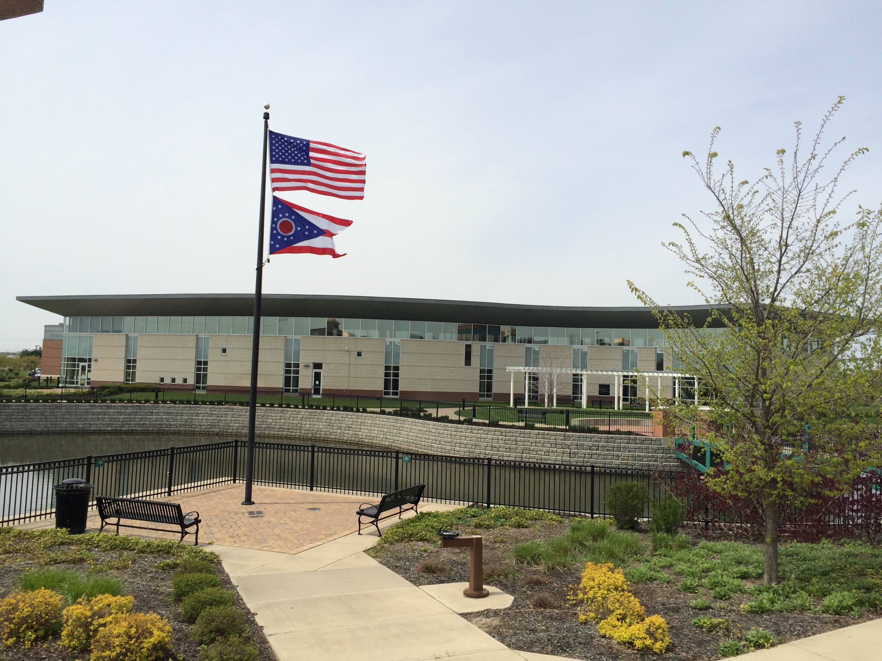
Draft Agenda
Board of Trustees—MidPointe Library System
February 19, 2025
1:00 p.m. Regular Meeting
West Chester Branch

- Call to Order
- Opening Exercise

- Roll Call
- Oath of Office
- Board Documents
  - Board Roster
  - Committee Assignments
  - Board Calendar
- Adoption of Agenda

- Public Comment
- Approval of Minutes
Approve the January 15, 2025, Organizational Meeting Minutes
- Fiscal Officer’s Report
  - January 2025 Financial Report, Investments, and Donations
  - Credit Card Audit Report (from Amy Abernathy)

- Director’s Report
  - Public Policy Manual Updates
- Facilities Director Updates
  - Yankee Road Project Updates

- Public Services Report
- Community Engagement Report
  - Communico Contract Renewal
- Human Resources Report
  - Staffing and HR Updates

- Board Comments
- Adjournment
Enclosures:

Draft of the January 15, 2025 Organizational Meeting Minutes
Board Roster
Committee Assignments
Board Calendar
January 2025 Financial Report
Credit Card Audit Report
Director’s Report
Public Services Report
Community Engagement Report
Communico Contract Renewal
Staffing and HR Updates

