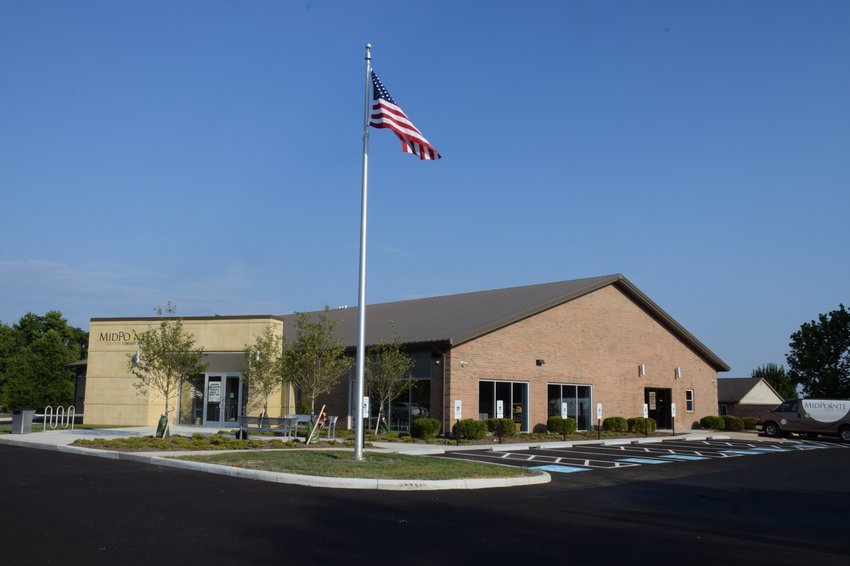
Draft Agenda
Board of Trustees—MidPointe Library System
March 19, 2025
1:00 p.m. Regular Meeting
Trenton Branch

- Call to Order
- Opening Exercise

- Roll Call
- Adoption of Agenda

- Public Comment

- Approval of Minutes
Approve the February 19, 2025, Regular Meeting Minutes
- Fiscal Officer’s Report
  - February 2024 Financial Report, Investments, and Donations

- 2025 Credit Card Report – Amy Abernathy, Compliance Officer
- Director’s Report
  - Public Policy Manual (Naming Rights)
- Facilities Report
- Public Services Report
- Community Engagement Report
- Human Resources Report
  - Staffing and HR Updates

- Board Comments
- Adjournment
Enclosures:
Draft of the February 19, 2025 Meeting Minutes
2025 Credit Card Compliance Report
Director’s Report
Community Engagement Report
Staffing and HR Updates

