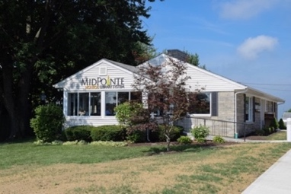

Draft Agenda
Board of Trustees—MidPointe Library System
April 16, 2025
1:00 p.m. Regular Meeting
Monroe Branch – Rothwell Room
- Call to Order

- Opening Exercise

- Roll Call
- Adoption of Agenda

- Public Comment

- Approval of Minutes (Regular Meeting, March 19, 2025)
- Fiscal Officer’s Report
  - Financial Report, Investments, and Donations
  - Reclassification Project
  - Appropriation Amendment
  - County Budget Update
- Credit Card Audit Report – Amy Abernathy

- Director’s Report
  - Fundraising Policy
  - Funding Updates

- Facilities Report

- Public Services Report
- Community Engagement Report
- Human Resources Report
- Board Comments
- Adjournment

Enclosures:
Draft of the March 19, 2025, Meeting Minutes
March 2025 Financial Report
Appropriation Amendment
Credit Card Audit Report
Director’s Report
Fundraising Policy Draft
Public Services Report
Community Engagement Report
HR Report

